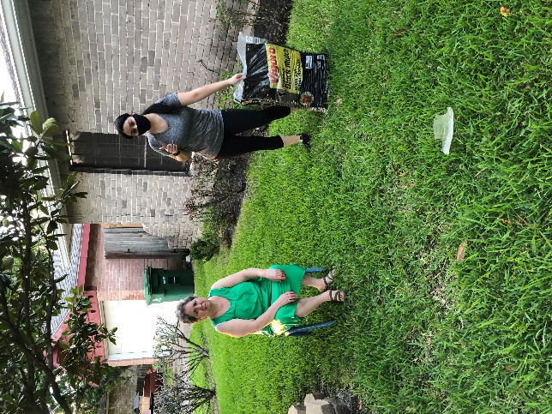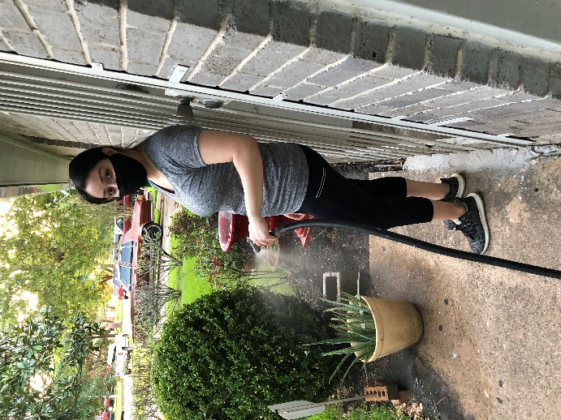
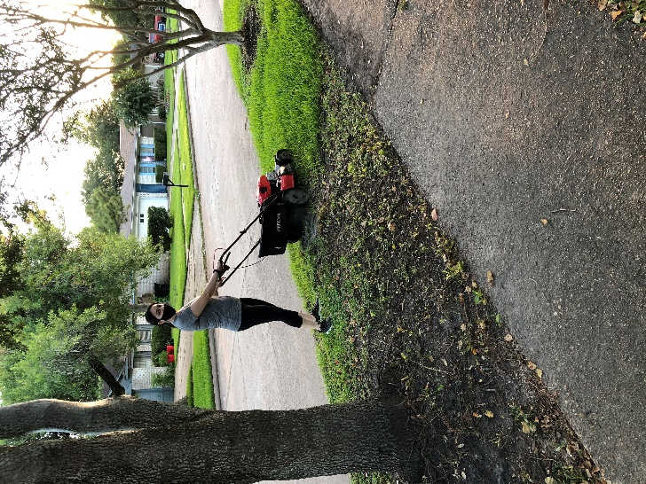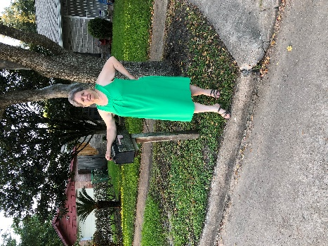
I live in Houston Tx. 77053.
This is my front neighbor Martha (green dress).
She lives with her husband that works Monday- Saturday, She is retired and stays at home.
I decided to help out on their front yard on August 7, 2020.

